Moxamu Pty Limited
ABN 45 002 101 804 1/as
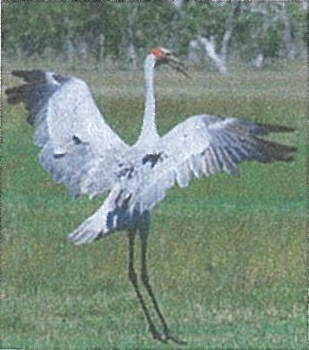 | Lawrence Bus Service  65 Richmond Street, Lawrence NSW 2460 Phone (02)66477279 Fax (02)66477144 Mobile. 0418 207760  email : fiveksAbigpond.com

20th August 2012
Australian Human Rights Commission /PO Box 5218
SYDNEY NSW 2001.
Dear Sir/Madam,
Request for Exemption from DDA
Please find enclosed correspondence between ourselves and Transport for NSW (TfNSW) re compliance with DDA provisions.
It would be appreciated if you could assess our request for exemption based on our letter to TfNSW and advise accordingly.
Yours Faithfully,
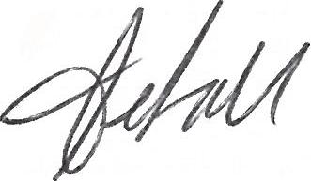
Peter Kelsall Lawrence Bus Service
401.
GOVERNMENT
401.  GOVERNMENT | Transport

Mr P Kelsall
Director
Moxamu Pty Ltd
65 Richmond Street
LAWRENCE NSW 2460
Dear Mr Kelsall
I refer to your correspondence dated 9 July 2012 requesting an exemption from compliance with the accessible transport provisions of the Disability Discrimination Act (DDA).
I acknowledge your comments and note that you have indicated that Moxamu Pty Ltd is unable to comply with accessible transport standards.
Transport for NSW (TfNSW) does not have the authority to grant an exemption from compliance with the DDA, nor can it provide advice on undue financial hardship or equivalent access plans. These matters are the responsibility of the Human Rights & Equal Opportunity Commission (HREOC).
I would suggest that you raise your concerns about DDA compliance with HREOC. Please keep TfNSW updated with respect to this matter.
A copy of your letter will be retained on TfNSW files. Yours sincerely
Nicole O'Neill
Manager — Contracts & Schemes
17 August 2012
Ground Floor, 239 King Street Newcastle NSW 2300
PO Box 871 Newcastle NSW 2300
Toll Free 1800 049 983 T 02 4929 7006 F 02 4929 6288
www.transport.nsw.gov.au
ABN 11 370 995 518
Moxamu Pty Limited
ABN 45 002 101 804 1/as
Cont. on Page 2
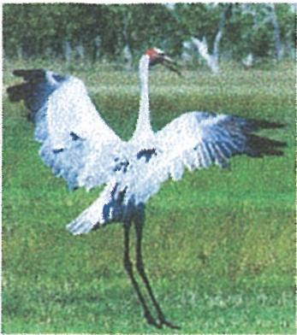 | Lawrence Bus Service  65 Richmond Street, Lawrence NSW 2460 Phone (02)66477279  Fax (02)66477144 Mobile. 0418 207760  email : fiveks(bigpond.com

9th July 2012
Regional Manager
Transport for NSW PO Box 871
Newcastle NSW 2300.
Re: Disability Discrimination Act
Dear Sir,
In response to your letter of 3 July 2012 I am writing to request an exemption from complying with the above Act on the following grounds.
Firstly, I would like to advise that our business operates 1 x 24 seat vehicle on an A contract (A697) and 2 x 57 seat buses on a B contract (B055). Both of those large buses need to be 57 seaters to be able to carry our student numbers. In addition to the above school services we operate 3 regular passenger scheduled town services per week.
- Due to the necessity of crossing the Bluff Point Ferry at Lawrence we are unable to operate low floor vehicles in this area. In fact, I can advise that even a normal height country school bus is unable to use this ferry. It has been necessary for us to have all of our buses specially built or modified, at great expense, to enable us to conduct normal operations.
- There are no footpaths in Lawrence at all and only one street has kerb and guttering and then only on one side of the road. The road verge on that street slopes away rapidly from the gutter and is not suitable for wheelchair access.
- The roads and streets in the village and on the main roads to Maclean and Grafton are narrow, badly formed, in generally poor condition and the road side edges slope away quickly into the table drain beside the road.
I would like to advise Transport for NSW of the special assistance we provide to all of our passengers and particularly to those who are in need of extra help.
- Assistance provided with groceries on and off the bus
- Passengers delivered directly to their door by driving "off route"
- When the bus is in Maclean and Grafton on Town Service runs the bus is left open and staffed so that passengers may come and go with groceries etc. and obtain assistance from the driver as needed.
- On return to Lawrence we routinely stop at the Lawrence Post Office and wait for passengers to collect their mail and parcels, conduct business etc. This is a vital additional service as most of our passengers do not have a motor vehicle and a large portion of Lawrence does not get a mail delivery service.
Page 2.
To provide Transport for NSW with an idea of the financial constraints we face our town service runs for June 2012 returned average cash fares of $21.20 for Grafton and $18.80 for Maclean. Please note that the Grafton Town service has a labour cost of 5 hours with a return journey of 75 kilometres.
The Maclean Town service has a labour cost of 3.5 hours with a return journey of 35 kilometres.
We believe it would cause unjustifiable financial hardship to require us to try and design, build and operate a specific vehicle for town service runs considering the significant losses which these runs already accrue.
Further, because there are no medical or related facilities in Lawrence and due to the distance and time involved in getting to Maclean and Grafton people with disabilities or serious illnesses invariably move into town so that they may readily access those facilities.
In conclusion I would like to summarise with the following points-
- The local road network and infrastructure is not to a standard that would allow disabled access to a bus.
- Don't believe it is technically possible to achieve an accessible bus due to Bluff Point Ferry.
- Already presently go to great lengths to assist our passengers and would be prepared to look at further options in that area if any are suggested.
- Undue financial hardship would be caused by forcing us to comply.
- We believe we have no market for an accessible bus and we certainly have never had any request for same.
Please contact the writer if you require further information.
Yours'aithfully,
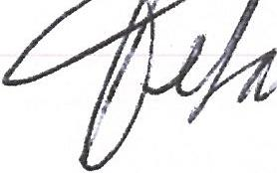
Peter M. Kelsall
Director
Moxamu Pty Ltd
T/as Lawrence Bus Service
NSW  GOVERNMENT | Transport

3 July 2012
TO: RURAL AND REGIONAL CONTRACT B OPERATORS
Dear Operator
I am writing in regard to Schedule 8 and clauses 3.3 and 7.1(d) of the Standard Terms & Conditions of your Rural and Regional Bus Service Contract B.
Currently, Services (other than Dedicated School Services) operated under the Contract must satisfy the requirement to provide Disability Discrimination Act, 1992 compliant buses on 25% of the regular passenger services that you provide.
You are advised that from 31 December 2012, the Disability Standards for Accessible Public Transport, 2002, under the Disability Discrimination Act, will require that 55% of all regular passenger services are operated on Disability Discrimination Act compliant buses.
Please review your bus fleet and the regular passenger services operated under the Contract and provide a response to Transport for NSW by 6 August 2012 detailing your action plan to meet this legislated requirement.
Should you wish to discuss this requirement please contact Nicole O'Neill, Contracts and Schemes Manager on the telephone numbers provided.
Yo rs sincerely
P W Sullivan
Regional Manager Northern Region

